Packages installed
> library(lattice)
Warning message:
package ‘lattice’ was built under R version 3.5.3
> library(psych)
Warning message:
package ‘psych’ was built under R version 3.5.3
> library(MASS)

Attaching package: ‘MASS’

The following object is masked from ‘package:dplyr’:

select

> str(raw)
'data.frame': 3541 obs. of 55 variables:
$ Num : int 1 2 3 4 5 6 7 8 9 10 ...
$ Default...1 : int 0 0 1 0 0 0 0 0 0 0 ...
$ Networth.Next.Year : num 8890.6 394.3 92.2 2.7 109 ...
$ Total.assets : num 17512.3 941 232.8 2.7 478.5 ...
$ Net.worth : num 7093.2 351.5 100.6 2.7 107.6 ...
$ Total.income : num 24965 1527 477 NA 1580 ...
$ Change.in.stock : num 235.8 42.7 -5.2 NA -17 ...
$ Total.expenses : num 23658 1455 479 NA 1558 ...
$ Profit.after.tax : num 1543.2 115.2 -6.6 NA 5.5 ...
$ PBDITA : num 2860.2 283 5.8 NA 31 ...
$ PBT : num 2417.2 188.4 -6.6 NA 6.3 ...
$ Cash.profit : num 1872.8 158.6 0.3 NA 11.9 ...
$ PBDITA.as...of.total.income : num 11.46 18.53 1.22 0 1.96 ...
$ PBT.as...of.total.income : num 9.68 12.33 -1.38 0 0.4 ...
$ PAT.as...of.total.income : num 6.18 7.54 -1.38 0 0.35 2.81 0 0.72 8.29 -2.88 ...
$ Cash.profit.as...of.total.income : num 7.5 10.38 0.06 0 0.75 ...
$ PAT.as...of.net.worth : num 23.78 38.08 -6.35 0 5.25 ...
$ Sales : num 24458 1504 476 NA 1575 ...
$ Income.from.financial.services : num 158 4 1.5 NA 3.9 6.4 NA NA 7.3 NA ...
$ Other.income : num 297.2 15.9 0.2 NA 0.9 ...
$ Total.capital : num 423.8 115.5 81.4 0.5 6.2 ...
$ Reserves.and.funds : num 6822.8 257.8 19.2 2.2 161.8 ...
$ Deposits..accepted.by.commercial.banks. : logi NA NA NA NA NA NA ...
$ Borrowings : num 14.9 272.5 35.4 NA 193.1 ...
$ Current.liabilities...provisions : num 9965.9 210 96.8 NA 112.8 ...
$ Deferred.tax.liability : num 284.9 85.2 NA NA 4.6 ...
$ Shareholders.funds : num 7093.2 351.5 100.6 2.7 107.6 ...
$ Cumulative.retained.profits : num 6263.3 247.4 32.4 2.2 82.7 ...
$ Capital.employed : num 7108.1 624 136 2.7 300.7 ...
$ TOL.TNW : num 1.33 1.23 1.44 0 2.83 1.8 0.03 5.17 1.05 3.25 ...
$ Total.term.liabilities...tangible.net.worth: num 0 0.34 0.29 0 1.59 0.37 0.03 0.94 0.3 0.54 ...
$ Contingent.liabilities...Net.worth.... : num 14.8 19.2 45.8 0 34.9 ...
$ Contingent.liabilities : num 1049.7 67.6 46.1 NA 37.6 ...
$ Net.fixed.assets : num 1900.2 286.4 38.7 2.5 94.8 ...
$ Investments : num 1069.6 2.2 4.3 NA 7.4 ...
$ Current.assets : num 13277.5 563.9 167.5 0.2 349.7 ...
$ Net.working.capital : num 3588.5 203.5 59.6 0.2 215.8 ...
$ Quick.ratio..times. : num 1.18 0.95 1.11 NA 1.41 0.48 NA 0.54 0.59 0.39 ...
$ Current.ratio..times. : num 1.37 1.56 1.55 NA 2.54 1.27 NA 1.15 1.58 0.5 ...
$ Debt.to.equity.ratio..times. : num 0 0.78 0.35 0 1.79 1.09 0.32 2.31 0.94 3.13 ...
$ Cash.to.current.liabilities..times. : num 0.43 0.06 0.21 NA 0 0.11 NA 0.04 0.19 0 ...
$ Cash.to.average.cost.of.sales.per.day : num 68.21 5.96 17.07 NA 0 ...
$ Creditors.turnover : num 3.62 9.8 5.28 0 13 ...
$ Debtors.turnover : num 3.85 5.7 5.07 0 9.46 ...
$ Finished.goods.turnover : num 200.55 14.21 9.24 NA 12.68 ...
$ WIP.turnover : num 21.78 7.49 0.23 NA 7.9 ...
$ Raw.material.turnover : num 7.71 11.46 NA 0 17.03 ...
$ Shares.outstanding : num 42381675 11550000 8149090 52404 619635 ...
$ Equity.face.value : num 10 10 10 10 10 10 10 NA 10 10 ...
$ EPS : num 35.52 9.97 -0.5 0 7.91 ...
$ Adjusted.EPS : num 7.1 9.97 -0.5 0 7.91 ...
$ Total.liabilities : num 17512.3 941 232.8 2.7 478.5 ...
$ PE.on.BSE : num 27.31 8.17 -5.76 NA NA ...
$ X : num 42574476 NA NA NA NA ...
$ X.1 : Factor w/ 5 levels "","leverage",..: 1 1 1 1 1 4 3 2 5 1 ...

Data names

> describe(raw)
vars n
Num 1 3541
Default...1 2 715
Networth.Next.Year 3 3541
Total.assets 4 3541
Net.worth 5 3541
Total.income 6 3343
Change.in.stock 7 3083
Total.expenses 8 3402
Profit.after.tax 9 3410
PBDITA 10 3410
PBT 11 3410
Cash.profit 12 3410
PBDITA.as...of.total.income 13 3473
PBT.as...of.total.income 14 3473
PAT.as...of.total.income 15 3473
Cash.profit.as...of.total.income 16 3473
PAT.as...of.net.worth 17 3541
Sales 18 3282
Income.from.financial.services 19 2606
Other.income 20 2246
Total.capital 21 3537
Reserves.and.funds 22 3456
Deposits..accepted.by.commercial.banks. 23 0
Borrowings 24 3175
Current.liabilities...provisions 25 3445
Deferred.tax.liability 26 2401
Shareholders.funds 27 3541
Cumulative.retained.profits 28 3503
Capital.employed 29 3541
TOL.TNW 30 3541
Total.term.liabilities...tangible.net.worth 31 3541
Contingent.liabilities...Net.worth.... 32 3541
Contingent.liabilities 33 2353
Net.fixed.assets 34 3423
Investments 35 2106
Current.assets 36 3475
Net.working.capital 37 3509
Quick.ratio..times. 38 3448
Current.ratio..times. 39 3448
Debt.to.equity.ratio..times. 40 3541
Cash.to.current.liabilities..times. 41 3448
Cash.to.average.cost.of.sales.per.day 42 3456
Creditors.turnover 43 3208
Debtors.turnover 44 3213
Finished.goods.turnover 45 2801
WIP.turnover 46 2901
Raw.material.turnover 47 3180
Shares.outstanding 48 2849
Equity.face.value 49 2849
EPS 50 3541
Adjusted.EPS 51 3541
Total.liabilities 52 3541
PE.on.BSE 53 1347
X 54 1
X.1* 55 3541
mean
Num 1772.45
Default...1 0.08
Networth.Next.Year 1616.26
Total.assets 3443.38
Net.worth 1295.86
Total.income 4582.82
Change.in.stock 41.49
Total.expenses 4262.93
Profit.after.tax 277.36
PBDITA 578.06
PBT 383.81
Cash.profit 392.07
PBDITA.as...of.total.income 4.57
PBT.as...of.total.income -17.28
PAT.as...of.total.income -19.20
Cash.profit.as...of.total.income -8.23
PAT.as...of.net.worth 10.27
Sales 4549.52
Income.from.financial.services 80.84
Other.income 41.36
Total.capital 216.61
Reserves.and.funds 1163.81
Deposits..accepted.by.commercial.banks. NaN
Borrowings 1122.28
Current.liabilities...provisions 940.63
Deferred.tax.liability 227.22
Shareholders.funds 1322.07
Cumulative.retained.profits 890.51
Capital.employed 2328.35
TOL.TNW 3.99
Total.term.liabilities...tangible.net.worth 1.84
Contingent.liabilities...Net.worth.... 53.94
Contingent.liabilities 932.92
Net.fixed.assets 1189.68
Investments 694.73
Current.assets 1293.36
Net.working.capital 138.57
Quick.ratio..times. 1.40
Current.ratio..times. 2.13
Debt.to.equity.ratio..times. 2.78
Cash.to.current.liabilities..times. 0.49
Cash.to.average.cost.of.sales.per.day 158.44
Creditors.turnover 15.45
Debtors.turnover 17.04
Finished.goods.turnover 87.08
WIP.turnover 27.93
Raw.material.turnover 19.09
Shares.outstanding 22067387.54
Equity.face.value -1333.70
EPS -220.32
Adjusted.EPS -221.51
Total.liabilities 3443.38
PE.on.BSE 63.91
X 42574475.56
X.1* 1.00
sd
Num 1023.73
Default...1 0.26
Networth.Next.Year 17459.64
Total.assets 30970.89
Net.worth 13387.89
Total.income 55681.24
Change.in.stock 440.57
Total.expenses 53028.69
Profit.after.tax 3064.41
PBDITA 5653.77
PBT 4117.07
Cash.profit 4226.64
PBDITA.as...of.total.income 147.12
PBT.as...of.total.income 425.43
PAT.as...of.total.income 429.81
Cash.profit.as...of.total.income 304.57
PAT.as...of.net.worth 65.15
Sales 54964.65
Income.from.financial.services 1115.17
Other.income 917.29
Total.capital 1682.59
Reserves.and.funds 13372.68
Deposits..accepted.by.commercial.banks. NA
Borrowings 8681.92
Current.liabilities...provisions 9546.09
Deferred.tax.liability 2170.21
Shareholders.funds 13445.29
Cumulative.retained.profits 10112.38
Capital.employed 21069.01
TOL.TNW 19.40
Total.term.liabilities...tangible.net.worth 14.77
Contingent.liabilities...Net.worth.... 378.84
Contingent.liabilities 12973.32
Net.fixed.assets 13291.91
Investments 6895.54
Current.assets 10131.77
Net.working.capital 2945.48
Quick.ratio..times. 7.73
Current.ratio..times. 10.11
Debt.to.equity.ratio..times. 14.97
Cash.to.current.liabilities..times. 4.20
Cash.to.average.cost.of.sales.per.day 2746.90
Creditors.turnover 68.21
Debtors.turnover 83.94
Finished.goods.turnover 598.55
WIP.turnover 151.04
Raw.material.turnover 376.34
Shares.outstanding 165519303.66
Equity.face.value 37500.73
EPS 14261.95
Adjusted.EPS 14261.92
Total.liabilities 30970.89
PE.on.BSE 1433.81
X NA
X.1* 0.09
median
Num 1773.00
Default...1 0.00
Networth.Next.Year 116.30
Total.assets 309.70
Net.worth 102.30
Total.income 444.90
Change.in.stock 1.60
Total.expenses 407.70
Profit.after.tax 8.80
PBDITA 35.40
PBT 12.40
Cash.profit 18.85
PBDITA.as...of.total.income 9.66
PBT.as...of.total.income 3.31
PAT.as...of.total.income 2.34
Cash.profit.as...of.total.income 5.64
PAT.as...of.net.worth 7.92
Sales 453.10
Income.from.financial.services 1.80
Other.income 1.40
Total.capital 42.10
Reserves.and.funds 54.80
Deposits..accepted.by.commercial.banks. NA
Borrowings 99.20
Current.liabilities...provisions 69.40
Deferred.tax.liability 13.40
Shareholders.funds 105.60
Cumulative.retained.profits 37.10
Capital.employed 214.70
TOL.TNW 1.43
Total.term.liabilities...tangible.net.worth 0.34
Contingent.liabilities...Net.worth.... 5.33
Contingent.liabilities 38.00
Net.fixed.assets 93.50
Investments 8.35
Current.assets 145.10
Net.working.capital 16.20
Quick.ratio..times. 0.67
Current.ratio..times. 1.23
Debt.to.equity.ratio..times. 0.79
Cash.to.current.liabilities..times. 0.07
Cash.to.average.cost.of.sales.per.day 8.02
Creditors.turnover 6.09
Debtors.turnover 6.32
Finished.goods.turnover 17.27
WIP.turnover 9.76
Raw.material.turnover 6.40
Shares.outstanding 4672063.00
Equity.face.value 10.00
EPS 1.43
Adjusted.EPS 1.18
Total.liabilities 309.70
PE.on.BSE 9.10
X 42574475.56
X.1* 1.00
trimmed
Num 1772.31
Default...1 0.00
Networth.Next.Year 265.91
Total.assets 643.26
Net.worth 220.77
Total.income 827.39
Change.in.stock 7.93
Total.expenses 774.78
Profit.after.tax 30.25
PBDITA 86.81
PBT 41.89
Cash.profit 52.48
PBDITA.as...of.total.income 10.51
PBT.as...of.total.income 4.47
PAT.as...of.total.income 3.22
Cash.profit.as...of.total.income 6.33
PAT.as...of.net.worth 10.21
Sales 829.84
Income.from.financial.services 6.34
Other.income 3.50
Total.capital 61.40
Reserves.and.funds 160.31
Deposits..accepted.by.commercial.banks. NaN
Borrowings 205.91
Current.liabilities...provisions 152.13
Deferred.tax.liability 29.36
Shareholders.funds 228.96
Cumulative.retained.profits 116.20
Capital.employed 440.77
TOL.TNW 1.74
Total.term.liabilities...tangible.net.worth 0.53
Contingent.liabilities...Net.worth.... 15.04
Contingent.liabilities 107.04
Net.fixed.assets 198.87
Investments 43.85
Current.assets 286.21
Net.working.capital 42.49
Quick.ratio..times. 0.74
Current.ratio..times. 1.33
Debt.to.equity.ratio..times. 1.00
Cash.to.current.liabilities..times. 0.12
Cash.to.average.cost.of.sales.per.day 13.78
Creditors.turnover 7.78
Debtors.turnover 7.81
Finished.goods.turnover 25.14
WIP.turnover 12.94
Raw.material.turnover 7.52
Shares.outstanding 6865618.23
Equity.face.value 10.17
EPS 4.93
Adjusted.EPS 4.02
Total.liabilities 643.26
PE.on.BSE 10.46
X 42574475.56
X.1* 1.00
mad
Num 1313.58
Default...1 0.00
Networth.Next.Year 159.53
Total.assets 402.08
Net.worth 134.03
Total.income 605.49
Change.in.stock 10.82
Total.expenses 562.50
Profit.after.tax 15.42
PBDITA 51.00
PBT 20.90
Cash.profit 27.95
PBDITA.as...of.total.income 8.07
PBT.as...of.total.income 4.91
PAT.as...of.total.income 3.47
Cash.profit.as...of.total.income 6.08
PAT.as...of.net.worth 11.74
Sales 609.94
Income.from.financial.services 2.52
Other.income 1.93
Total.capital 49.82
Reserves.and.funds 90.51
Deposits..accepted.by.commercial.banks. NA
Borrowings 135.36
Current.liabilities...provisions 94.59
Deferred.tax.liability 18.09
Shareholders.funds 138.77
Cumulative.retained.profits 71.76
Capital.employed 278.28
TOL.TNW 1.48
Total.term.liabilities...tangible.net.worth 0.50
Contingent.liabilities...Net.worth.... 7.90
Contingent.liabilities 54.41
Net.fixed.assets 123.65
Investments 12.08
Current.assets 196.74
Net.working.capital 46.11
Quick.ratio..times. 0.46
Current.ratio..times. 0.53
Debt.to.equity.ratio..times. 1.02
Cash.to.current.liabilities..times. 0.09
Cash.to.average.cost.of.sales.per.day 9.63
Creditors.turnover 4.75
Debtors.turnover 4.98
Finished.goods.turnover 16.69
WIP.turnover 8.70
Raw.material.turnover 5.92
Shares.outstanding 5740720.60
Equity.face.value 0.00
EPS 2.95
Adjusted.EPS 2.46
Total.liabilities 402.08
PE.on.BSE 10.33
X 0.00
X.1* 0.00
min
Num 1.000000e+00
Default...1 0.000000e+00
Networth.Next.Year -7.426560e+04
Total.assets 1.000000e-01
Net.worth 0.000000e+00
Total.income 0.000000e+00
Change.in.stock -3.029400e+03
Total.expenses -1.000000e-01
Profit.after.tax -3.908300e+03
PBDITA -4.407000e+02
PBT -3.894800e+03
Cash.profit -2.245700e+03
PBDITA.as...of.total.income -6.400000e+03
PBT.as...of.total.income -2.134000e+04
PAT.as...of.total.income -2.134000e+04
Cash.profit.as...of.total.income -1.502000e+04
PAT.as...of.net.worth -7.487200e+02
Sales 1.000000e-01
Income.from.financial.services 0.000000e+00
Other.income 0.000000e+00
Total.capital 1.000000e-01
Reserves.and.funds -6.525900e+03
Deposits..accepted.by.commercial.banks. Inf
Borrowings 1.000000e-01
Current.liabilities...provisions 1.000000e-01
Deferred.tax.liability 1.000000e-01
Shareholders.funds 0.000000e+00
Cumulative.retained.profits -6.534300e+03
Capital.employed 0.000000e+00
TOL.TNW -3.504800e+02
Total.term.liabilities...tangible.net.worth -3.256000e+02
Contingent.liabilities...Net.worth.... 0.000000e+00
Contingent.liabilities 1.000000e-01
Net.fixed.assets 0.000000e+00
Investments 0.000000e+00
Current.assets 1.000000e-01
Net.working.capital -6.383900e+04
Quick.ratio..times. 0.000000e+00
Current.ratio..times. 0.000000e+00
Debt.to.equity.ratio..times. 0.000000e+00
Cash.to.current.liabilities..times. 0.000000e+00
Cash.to.average.cost.of.sales.per.day 0.000000e+00
Creditors.turnover 0.000000e+00
Debtors.turnover 0.000000e+00
Finished.goods.turnover -9.000000e-02
WIP.turnover -1.800000e-01
Raw.material.turnover -2.000000e+00
Shares.outstanding -2.147484e+09
Equity.face.value -9.999989e+05
EPS -8.431818e+05
Adjusted.EPS -8.431818e+05
Total.liabilities 1.000000e-01
PE.on.BSE -1.116640e+03
X 4.257448e+07
X.1* 1.000000e+00
max
Num 3.545000e+03
Default...1 1.000000e+00
Networth.Next.Year 8.057734e+05
Total.assets 1.176509e+06
Net.worth 6.131516e+05
Total.income 2.442828e+06
Change.in.stock 1.418550e+04
Total.expenses 2.366035e+06
Profit.after.tax 1.194391e+05
PBDITA 2.085765e+05
PBT 1.452926e+05
Cash.profit 1.769118e+05
PBDITA.as...of.total.income 1.000000e+02
PBT.as...of.total.income 1.000000e+02
PAT.as...of.total.income 1.500000e+02
Cash.profit.as...of.total.income 1.000000e+02
PAT.as...of.net.worth 2.466670e+03
Sales 2.384984e+06
Income.from.financial.services 5.193820e+04
Other.income 4.285670e+04
Total.capital 7.827320e+04
Reserves.and.funds 6.251378e+05
Deposits..accepted.by.commercial.banks. -Inf
Borrowings 2.782573e+05
Current.liabilities...provisions 3.522403e+05
Deferred.tax.liability 7.279660e+04
Shareholders.funds 6.131516e+05
Cumulative.retained.profits 3.901338e+05
Capital.employed 8.914089e+05
TOL.TNW 4.730000e+02
Total.term.liabilities...tangible.net.worth 4.560000e+02
Contingent.liabilities...Net.worth.... 1.470427e+04
Contingent.liabilities 5.595068e+05
Net.fixed.assets 6.366046e+05
Investments 1.999786e+05
Current.assets 3.548152e+05
Net.working.capital 8.578280e+04
Quick.ratio..times. 3.410000e+02
Current.ratio..times. 5.050000e+02
Debt.to.equity.ratio..times. 4.560000e+02
Cash.to.current.liabilities..times. 1.650000e+02
Cash.to.average.cost.of.sales.per.day 1.280408e+05
Creditors.turnover 2.401000e+03
Debtors.turnover 3.135200e+03
Finished.goods.turnover 1.794760e+04
WIP.turnover 5.651400e+03
Raw.material.turnover 2.109200e+04
Shares.outstanding 4.130401e+09
Equity.face.value 1.000000e+05
EPS 3.452253e+04
Adjusted.EPS 3.452253e+04
Total.liabilities 1.176509e+06
PE.on.BSE 5.100274e+04
X 4.257448e+07
X.1* 5.000000e+00
range
Num 3.544000e+03
Default...1 1.000000e+00
Networth.Next.Year 8.800390e+05
Total.assets 1.176509e+06
Net.worth 6.131516e+05
Total.income 2.442828e+06
Change.in.stock 1.721490e+04
Total.expenses 2.366035e+06
Profit.after.tax 1.233474e+05
PBDITA 2.090172e+05
PBT 1.491874e+05
Cash.profit 1.791575e+05
PBDITA.as...of.total.income 6.500000e+03
PBT.as...of.total.income 2.144000e+04
PAT.as...of.total.income 2.149000e+04
Cash.profit.as...of.total.income 1.512000e+04
PAT.as...of.net.worth 3.215390e+03
Sales 2.384984e+06
Income.from.financial.services 5.193820e+04
Other.income 4.285670e+04
Total.capital 7.827310e+04
Reserves.and.funds 6.316637e+05
Deposits..accepted.by.commercial.banks. -Inf
Borrowings 2.782572e+05
Current.liabilities...provisions 3.522402e+05
Deferred.tax.liability 7.279650e+04
Shareholders.funds 6.131516e+05
Cumulative.retained.profits 3.966681e+05
Capital.employed 8.914089e+05
TOL.TNW 8.234800e+02
Total.term.liabilities...tangible.net.worth 7.816000e+02
Contingent.liabilities...Net.worth.... 1.470427e+04
Contingent.liabilities 5.595067e+05
Net.fixed.assets 6.366046e+05
Investments 1.999786e+05
Current.assets 3.548151e+05
Net.working.capital 1.496218e+05
Quick.ratio..times. 3.410000e+02
Current.ratio..times. 5.050000e+02
Debt.to.equity.ratio..times. 4.560000e+02
Cash.to.current.liabilities..times. 1.650000e+02
Cash.to.average.cost.of.sales.per.day 1.280408e+05
Creditors.turnover 2.401000e+03
Debtors.turnover 3.135200e+03
Finished.goods.turnover 1.794769e+04
WIP.turnover 5.651580e+03
Raw.material.turnover 2.109400e+04
Shares.outstanding 6.277884e+09
Equity.face.value 1.099999e+06
EPS 8.777043e+05
Adjusted.EPS 8.777043e+05
Total.liabilities 1.176509e+06
PE.on.BSE 5.211938e+04
X 0.000000e+00
X.1* 4.000000e+00
skew
Num 0.00
Default...1 3.21
Networth.Next.Year 33.18
Total.assets 27.86
Net.worth 33.50
Total.income 32.35
Change.in.stock 18.92
Total.expenses 33.09
Profit.after.tax 26.28
PBDITA 25.90
PBT 24.04
Cash.profit 29.33
PBDITA.as...of.total.income -30.67
PBT.as...of.total.income -40.35
PAT.as...of.total.income -39.37
Cash.profit.as...of.total.income -38.40
PAT.as...of.net.worth 17.91
Sales 32.02
Income.from.financial.services 39.57
Other.income 45.37
Total.capital 33.73
Reserves.and.funds 35.23
Deposits..accepted.by.commercial.banks. NA
Borrowings 22.67
Current.liabilities...provisions 27.04
Deferred.tax.liability 24.86
Shareholders.funds 33.13
Cumulative.retained.profits 29.50
Capital.employed 30.07
TOL.TNW 10.57
Total.term.liabilities...tangible.net.worth 12.59
Contingent.liabilities...Net.worth.... 25.76
Contingent.liabilities 36.52
Net.fixed.assets 37.29
Investments 20.62
Current.assets 22.93
Net.working.capital 6.40
Quick.ratio..times. 30.24
Current.ratio..times. 38.26
Debt.to.equity.ratio..times. 16.99
Cash.to.current.liabilities..times. 28.23
Cash.to.average.cost.of.sales.per.day 36.04
Creditors.turnover 23.22
Debtors.turnover 25.48
Finished.goods.turnover 20.41
WIP.turnover 25.76
Raw.material.turnover 55.24
Shares.outstanding 8.94
Equity.face.value -26.51
EPS -58.35
Adjusted.EPS -58.35
Total.liabilities 27.86
PE.on.BSE 33.79
X NA
X.1* 36.16
kurtosis
Num -1.20
Default...1 8.29
Networth.Next.Year 1373.06
Total.assets 939.63
Net.worth 1370.66
Total.income 1235.99
Change.in.stock 479.11
Total.expenses 1290.22
Profit.after.tax 847.39
PBDITA 806.51
PBT 686.19
Cash.profit 1058.73
PBDITA.as...of.total.income 1148.62
PBT.as...of.total.income 1895.70
PAT.as...of.total.income 1821.62
Cash.profit.as...of.total.income 1762.39
PAT.as...of.net.worth 645.38
Sales 1208.80
Income.from.financial.services 1798.02
Other.income 2110.70
Total.capital 1418.53
Reserves.and.funds 1493.59
Deposits..accepted.by.commercial.banks. NA
Borrowings 646.42
Current.liabilities...provisions 858.81
Deferred.tax.liability 732.38
Shareholders.funds 1347.64
Cumulative.retained.profits 1020.07
Capital.employed 1114.06
TOL.TNW 249.36
Total.term.liabilities...tangible.net.worth 433.85
Contingent.liabilities...Net.worth.... 849.70
Contingent.liabilities 1499.07
Net.fixed.assets 1642.50
Investments 504.13
Current.assets 646.58
Net.working.capital 409.05
Quick.ratio..times. 1172.12
Current.ratio..times. 1805.46
Debt.to.equity.ratio..times. 380.57
Cash.to.current.liabilities..times. 956.67
Cash.to.average.cost.of.sales.per.day 1498.57
Creditors.turnover 690.98
Debtors.turnover 830.72
Finished.goods.turnover 491.96
WIP.turnover 820.13
Raw.material.turnover 3088.44
Shares.outstanding 288.31
Equity.face.value 703.15
EPS 3443.81
Adjusted.EPS 3443.81
Total.liabilities 939.63
PE.on.BSE 1184.09
X NA
X.1* 1387.19
se
Num 17.20
Default...1 0.01
Networth.Next.Year 293.41
Total.assets 520.46
Net.worth 224.98
Total.income 963.03
Change.in.stock 7.93
Total.expenses 909.17
Profit.after.tax 52.48
PBDITA 96.82
PBT 70.50
Cash.profit 72.38
PBDITA.as...of.total.income 2.50
PBT.as...of.total.income 7.22
PAT.as...of.total.income 7.29
Cash.profit.as...of.total.income 5.17
PAT.as...of.net.worth 1.09
Sales 959.43
Income.from.financial.services 21.85
Other.income 19.36
Total.capital 28.29
Reserves.and.funds 227.47
Deposits..accepted.by.commercial.banks. NA
Borrowings 154.08
Current.liabilities...provisions 162.64
Deferred.tax.liability 44.29
Shareholders.funds 225.95
Cumulative.retained.profits 170.86
Capital.employed 354.06
TOL.TNW 0.33
Total.term.liabilities...tangible.net.worth 0.25
Contingent.liabilities...Net.worth.... 6.37
Contingent.liabilities 267.45
Net.fixed.assets 227.19
Investments 150.26
Current.assets 171.87
Net.working.capital 49.72
Quick.ratio..times. 0.13
Current.ratio..times. 0.17
Debt.to.equity.ratio..times. 0.25
Cash.to.current.liabilities..times. 0.07
Cash.to.average.cost.of.sales.per.day 46.73
Creditors.turnover 1.20
Debtors.turnover 1.48
Finished.goods.turnover 11.31
WIP.turnover 2.80
Raw.material.turnover 6.67
Shares.outstanding 3101004.71
Equity.face.value 702.58
EPS 239.67
Adjusted.EPS 239.67
Total.liabilities 520.46
PE.on.BSE 39.07
X NA
X.1* 0.00

,1,0)
> table(default.model4$y,default.prediction4)
default.prediction4
0 1
0 1582 1716
1 21 222
> 22/(21+222)
[1] 0.09053498
> [1] 0.9588477
Error: unexpected '[' in "["
> > (10+233)/(1522+1776+10+233)
Error: unexpected '>' in ">"
> [1] 0.06862468
Error: unexpected '[' in "["
> > 1-(10+233)/(1522+1776+10+233)
Error: unexpected '>' in ">"
> [1] 0.9313753
Error: unexpected '[' in "["
> 21/(21+222)
[1] 0.08641975
> (21+222)/(21+222)+1582+1716)
Error: unexpected ')' in "(21+222)/(21+222)+1582+1716)"
> (21+222)/21+222+1582+1716)
Error: unexpected ')' in "(21+222)/21+222+1582+1716)"
> 21+222/21+222+1582+1716
[1] 3551.571
> (21+222)/(21+222+1582+1716)
[1] 0.06862468
> 1-(21+222)/(21+222+1582+1716)
[1] 0.9313753
,1,0)
> table(default.model4$y,default.prediction4)
default.prediction4
0 1
0 1582 1716
1 21 222
> 22/(21+222)
[1] 0.09053498
> [1] 0.9588477
Error: unexpected '[' in "["
> > (10+233)/(1522+1776+10+233)
Error: unexpected '>' in ">"
> [1] 0.06862468
Error: unexpected '[' in "["
> > 1-(10+233)/(1522+1776+10+233)
Error: unexpected '>' in ">"
> [1] 0.9313753
Error: unexpected '[' in "["
> 21/(21+222)
[1] 0.08641975
> (21+222)/(21+222)+1582+1716)
Error: unexpected ')' in "(21+222)/(21+222)+1582+1716)"
> (21+222)/21+222+1582+1716)
Error: unexpected ')' in "(21+222)/21+222+1582+1716)"
> 21+222/21+222+1582+1716
[1] 3551.571
> (21+222)/(21+222+1582+1716)
[1] 0.06862468
> 1-(21+222)/(21+222+1582+1716)
[1] 0.9313753
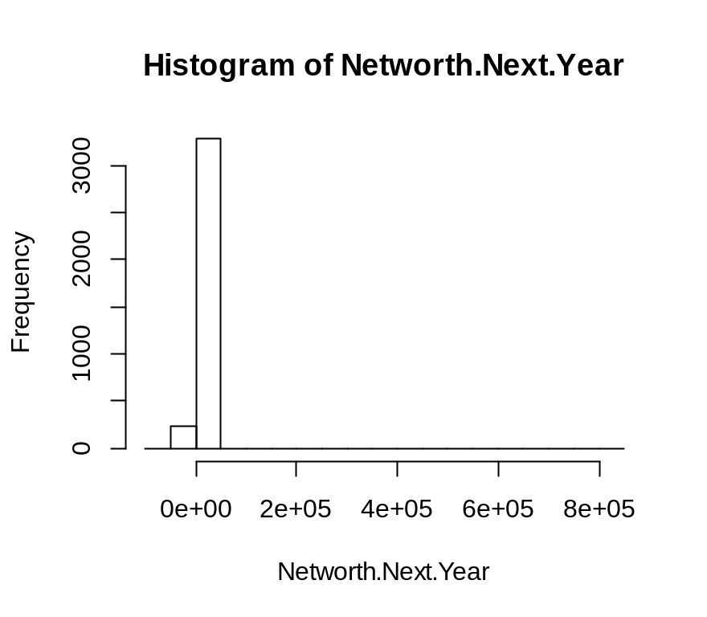

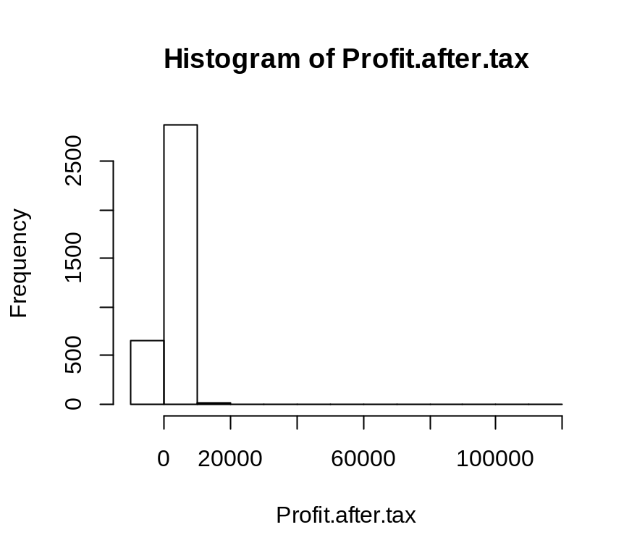

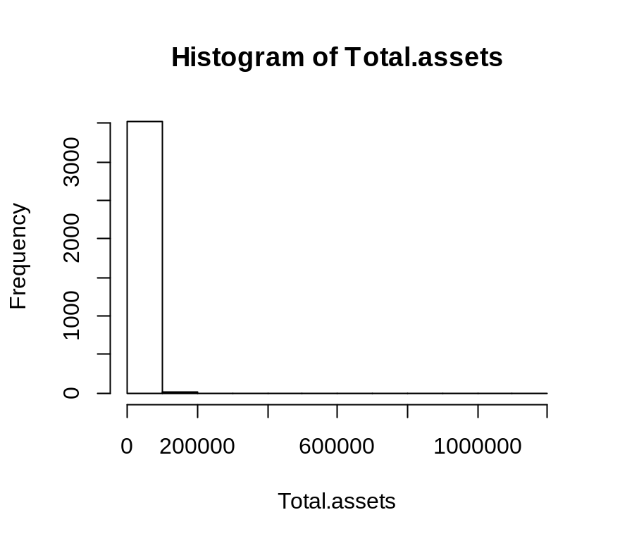summary(raw)
Num Default...1 Networth.Next.Year
Min. : 1 Min. :0.0000 Min. :-74265.6
1st Qu.: 886 1st Qu.:1.0000 1st Qu.: 31.7
Median :1773 Median :1.0000 Median : 116.3
Mean :1772 Mean :0.8133 Mean : 1616.3
3rd Qu.:2658 3rd Qu.:1.0000 3rd Qu.: 456.1
Max. :3545 Max. :1.0000 Max. :805773.4
Total.assets Net.worth
Min. : 0.1 Min. : 0.0
1st Qu.: 91.3 1st Qu.: 31.3
Median : 309.7 Median : 102.3
Mean : 3443.4 Mean : 1295.9
3rd Qu.: 1098.7 3rd Qu.: 377.3
Max. :1176509.2 Max. :613151.6
Total.income Change.in.stock
Min. : 0.0 Min. :-3029.40
1st Qu.: 75.6 1st Qu.: -0.70
Median : 371.0 Median : 1.00
Mean : 4326.6 Mean : 36.25
3rd Qu.: 1340.3 3rd Qu.: 13.40
Max. :2442828.2 Max. :14185.50
Total.expenses Profit.after.tax
Min. : -0.1 Min. : -3908.3
1st Qu.: 74.9 1st Qu.: 0.6
Median : 361.0 Median : 7.6
Mean : 4095.6 Mean : 267.1
3rd Qu.: 1284.6 3rd Qu.: 48.1
Max. :2366035.3 Max. :119439.1
PBDITA PBT Cash.profit
Min. : -440.7 Min. : -3894.8 Min. : -2245.7
1st Qu.: 5.1 1st Qu.: 0.9 1st Qu.: 1.9
Median : 32.1 Median : 10.5 Median : 16.7
Mean : 556.7 Mean : 369.6 Mean : 377.6
3rd Qu.: 139.1 3rd Qu.: 67.5 3rd Qu.: 86.8
Max. :208576.5 Max. :145292.6 Max. :176911.8
PBDITA.as...of.total.income PBT.as...of.total.income
Min. :-6400.000 Min. :-21340.00
1st Qu.: 4.690 1st Qu.: 0.60
Median : 9.380 Median : 3.17
Mean : 4.502 Mean : -16.93
3rd Qu.: 16.150 3rd Qu.: 8.63
Max. : 100.000 Max. : 100.00
PAT.as...of.total.income
Min. :-21340.00
1st Qu.: 0.39
Median : 2.27
Mean : -18.81
3rd Qu.: 6.25
Max. : 150.00
Cash.profit.as...of.total.income PAT.as...of.net.worth
Min. :-15020.000 Min. :-748.72
1st Qu.: 1.820 1st Qu.: 0.00
Median : 5.490 Median : 7.92
Mean : -8.052 Mean : 10.27
3rd Qu.: 10.560 3rd Qu.: 20.19
Max. : 100.000 Max. :2466.67
Sales Income.from.financial.services
Min. : 0.1 Min. : 0.00
1st Qu.: 70.8 1st Qu.: 0.70
Median : 358.3 Median : 1.00
Mean : 4216.8 Mean : 59.76
3rd Qu.: 1314.7 3rd Qu.: 5.40
Max. :2384984.4 Max. :51938.20
Other.income Total.capital Reserves.and.funds
Min. : 0.0 Min. : 0.1 Min. : -6525.9
1st Qu.: 0.8 1st Qu.: 13.0 1st Qu.: 3.3
Median : 1.0 Median : 42.1 Median : 50.2
Mean : 26.6 Mean : 216.4 Mean : 1135.9
3rd Qu.: 2.5 3rd Qu.: 100.3 3rd Qu.: 263.2
Max. :42856.7 Max. :78273.2 Max. :625137.8
Deposits..accepted.by.commercial.banks.
Min. :1
1st Qu.:1
Median :1
Mean :1
3rd Qu.:1
Max. :1
Borrowings Current.liabilities...provisions
Min. : 0.1 Min. : 0.1
1st Qu.: 11.4 1st Qu.: 14.9
Median : 75.1 Median : 64.6
Mean : 1006.4 Mean : 915.2
3rd Qu.: 296.0 3rd Qu.: 249.1
Max. :278257.3 Max. :352240.3
Deferred.tax.liability Shareholders.funds
Min. : 0.1 Min. : 0.0
1st Qu.: 1.0 1st Qu.: 32.0
Median : 3.5 Median : 105.6
Mean : 154.4 Mean : 1322.1
3rd Qu.: 26.9 3rd Qu.: 393.2
Max. :72796.6 Max. :613151.6
Cumulative.retained.profits Capital.employed
Min. : -6534.3 Min. : 0.0
1st Qu.: 1.0 1st Qu.: 60.8
Median : 36.2 Median : 214.7
Mean : 881.0 Mean : 2328.3
3rd Qu.: 199.4 3rd Qu.: 767.3
Max. :390133.8 Max. :891408.9
TOL.TNW
Min. :-350.480
1st Qu.: 0.600
Median : 1.430
Mean : 3.994
3rd Qu.: 2.830
Max. : 473.000
Total.term.liabilities...tangible.net.worth
Min. :-325.600
1st Qu.: 0.050
Median : 0.340
Mean : 1.844
3rd Qu.: 1.000
Max. : 456.000
Contingent.liabilities...Net.worth....
Min. : 0.00
1st Qu.: 0.00
Median : 5.33
Mean : 53.94
3rd Qu.: 30.76
Max. :14704.27
Contingent.liabilities Net.fixed.assets
Min. : 0.1 Min. : 0.0
1st Qu.: 1.0 1st Qu.: 22.0
Median : 6.2 Median : 87.0
Mean : 620.3 Mean : 1150.1
3rd Qu.: 84.2 3rd Qu.: 328.8
Max. :559506.8 Max. :636604.6
Investments Current.assets
Min. : 0.0 Min. : 0.1
1st Qu.: 1.0 1st Qu.: 32.4
Median : 1.0 Median : 137.9
Mean : 413.6 Mean : 1269.3
3rd Qu.: 16.1 3rd Qu.: 485.9
Max. :199978.6 Max. :354815.2
Net.working.capital Quick.ratio..times.
Min. :-63839.0 Min. : 0.000
1st Qu.: -1.0 1st Qu.: 0.420
Median : 15.7 Median : 0.680
Mean : 137.3 Mean : 1.391
3rd Qu.: 81.6 3rd Qu.: 1.020
Max. : 85782.8 Max. :341.000
Current.ratio..times. Debt.to.equity.ratio..times.
Min. : 0.000 Min. : 0.00
1st Qu.: 0.940 1st Qu.: 0.22
Median : 1.210 Median : 0.79
Mean : 2.101 Mean : 2.78
3rd Qu.: 1.690 3rd Qu.: 1.75
Max. :505.000 Max. :456.00
Cash.to.current.liabilities..times.
Min. : 0.0000
1st Qu.: 0.0200
Median : 0.0700
Mean : 0.5038
3rd Qu.: 0.2100
Max. :165.0000
Cash.to.average.cost.of.sales.per.day Creditors.turnover
Min. : 0.00 Min. : 0.00
1st Qu.: 2.56 1st Qu.: 2.81
Median : 7.57 Median : 5.50
Mean : 154.66 Mean : 14.09
3rd Qu.: 21.15 3rd Qu.: 10.55
Max. :128040.76 Max. :2401.00
Debtors.turnover Finished.goods.turnover
Min. : 0.00 Min. : -0.09
1st Qu.: 2.80 1st Qu.: 2.60
Median : 5.73 Median : 11.82
Mean : 15.56 Mean : 69.09
3rd Qu.: 10.82 3rd Qu.: 30.72
Max. :3135.20 Max. :17947.60
WIP.turnover Raw.material.turnover
Min. : -0.18 Min. : -2.00
1st Qu.: 2.22 1st Qu.: 1.69
Median : 7.42 Median : 5.60
Mean : 23.06 Mean : 17.24
3rd Qu.: 16.94 3rd Qu.: 10.92
Max. :5651.40 Max. :21092.00
Shares.outstanding Equity.face.value
Min. :-2.147e+09 Min. :-999999
1st Qu.: 1.250e+05 1st Qu.: 10
Median : 3.194e+06 Median : 10
Mean : 1.775e+07 Mean : -1073
3rd Qu.: 8.320e+06 3rd Qu.: 10
Max. : 4.130e+09 Max. : 100000
EPS Adjusted.EPS
Min. :-843181.8 Min. :-843181.8
1st Qu.: 0.0 1st Qu.: 0.0
Median : 1.4 Median : 1.2
Mean : -220.3 Mean : -221.5
3rd Qu.: 9.6 3rd Qu.: 7.5
Max. : 34522.5 Max. : 34522.5
Total.liabilities PE.on.BSE
Min. : 0.1 Min. :-1116.64
1st Qu.: 91.3 1st Qu.: 1.00
Median : 309.7 Median : 1.00
Mean : 3443.4 Mean : 24.93
3rd Qu.: 1098.7 3rd Qu.: 5.81
Max. :1176509.2 Max. :51002.74
X X.1
Min. : 1 :3537
1st Qu.: 1 leverage : 1
Median : 1 liquadity : 1
Mean : 12024 profatability: 1
3rd Qu.: 1 size : 1
Max. :42574476

Summaries of four predicted values

summary(Networth.Next.Year)
Min. 1st Qu. Median Mean 3rd Qu. Max.
-74265.6 31.7 116.3 1616.3 456.1 805773.4
> summary(Total.assets)
Min. 1st Qu. Median Mean 3rd Qu.
0.1 91.3 309.7 3443.4 1098.7
Max.
1176509.2
> summary(Profit.after.tax)
Min. 1st Qu. Median Mean 3rd Qu.
-3908.30 0.50 8.80 277.36 52.27
Max. NA's
119439.10 131
> summary(Total.term.liabilities...tangible.net.worth)
Min. 1st Qu. Median Mean 3rd Qu. Max.
-325.600 0.050 0.340 1.844 1.000 456.000
> summary(Creditors.turnover)
Min. 1st Qu. Median Mean 3rd Qu. Max.
0.000 3.700 6.095 15.446 11.490 2401.000
NA's
333
> default1(ifelse(Networth.Next.Year>0,0,1))
Error in default1(ifelse(Networth.Next.Year > 0, 0, 1)) :
could not find function "default1"
> default1<-ifelse(Networth.Next.Year>0,0,1)
> summary(default1)
Min. 1st Qu. Median Mean 3rd Qu. Max.
0.00000 0.00000 0.00000 0.06862 0.00000 1.00000
> summary(as.factor(default1))
0 1
3298 243
> 243/(3298+243)
[1] 0.06862468 The total default rate
> attach(raw)
The following objects are masked from raw (pos = 7):

Adjusted.EPS, Borrowings, Capital.employed,
Cash.profit, Cash.profit.as...of.total.income,
Cash.to.average.cost.of.sales.per.day,
Cash.to.current.liabilities..times.,
Change.in.stock, Contingent.liabilities,
Contingent.liabilities...Net.worth....,
Creditors.turnover,
Cumulative.retained.profits, Current.assets,
Current.liabilities...provisions,
Current.ratio..times.,
Debt.to.equity.ratio..times., Debtors.turnover,
Default...1, Deferred.tax.liability,
Deposits..accepted.by.commercial.banks., EPS,
Equity.face.value, Finished.goods.turnover,
Income.from.financial.services, Investments,
Net.fixed.assets, Net.working.capital,
Net.worth, Networth.Next.Year, Num,
Other.income, PAT.as...of.net.worth,
PAT.as...of.total.income, PBDITA,
PBDITA.as...of.total.income, PBT,
PBT.as...of.total.income, PE.on.BSE,
Profit.after.tax, Quick.ratio..times.,
Raw.material.turnover, Reserves.and.funds,
Sales, Shareholders.funds, Shares.outstanding,
TOL.TNW, Total.assets, Total.capital,
Total.expenses, Total.income,
Total.liabilities,
Total.term.liabilities...tangible.net.worth,
WIP.turnover, X, X.1

> View(raw)
> glm(as.factor(default1)~Total.assets,family = binomial)

Call: glm(formula = as.factor(default1) ~ Total.assets, family = binomial)

Coefficients:
(Intercept) Total.assets
-2.575e+00 -1.734e-05

Degrees of Freedom: 3540 Total (i.e. Null); 3539 Residual
Null Deviance: 1771
Residual Deviance: 1767 AIC: 1771

General linera model

> summary(glm(as.factor(default1)~Total.assets,family = binomial))

Call:
glm(formula = as.factor(default1) ~ Total.assets, family = binomial)

Deviance Residuals:
Min 1Q Median 3Q Max
-0.3832 -0.3829 -0.3819 -0.3779 3.0129

Coefficients:
Estimate Std. Error z value Pr(>|z|)
(Intercept) -2.575e+00 6.918e-02 -37.21 <2e-16 ***
Total.assets -1.734e-05 1.294e-05 -1.34 0.18
---
Signif. codes:
0 ‘***’ 0.001 ‘**’ 0.01 ‘*’ 0.05 ‘.’ 0.1 ‘ ’ 1

(Dispersion parameter for binomial family taken to be 1)

Null deviance: 1771.0 on 3540 degrees of freedom
Residual deviance: 1767.1 on 3539 degrees of freedom
AIC: 1771.1

Number of Fisher Scoring iterations: 7

> default.model1<-glm(as.factor(default1)~Total.assets,family = binomial)
> default.model1$fitted.values
1 2 3 4 5
0.05324013 0.06973029 0.07053123 0.07079329 0.07025240
6 7 8 9 10
0.06806883 0.07042410 0.07070516 0.07014452 0.07069536
11 12 13 14 15
0.07061450 0.06459525 0.06729394 0.07074300 0.07069969
16 17 18 19 20
0.06971533 0.07004696 0.07063556 0.07065959 0.07051668
21 22 23 24 25
0.07060665 0.06281079 0.06944026 0.07048975 0.07073034
26 27 28 29 30
0.07051611 0.07052737 0.06944015 0.07064661 0.07064319
31 32 33 34 35
0.07012202 0.07036088 0.07040752 0.07015742 0.07062737
36 37 38 39 40
0.07076820 0.07078314 0.07052396 0.07074129 0.07077766
41 42 43 44 45
0.07014859 0.07071792 0.07048327 0.07071792 0.07078120
46 47 48 49 50
0.06984693 0.06111559 0.07059789 0.07049793 0.06375618
51 52 53 54 55
0.07043466 0.07066209 0.07078725 0.07077995 0.06968744
56 57 58 59 60
0.07067257 0.07044102 0.06449651 0.07066096 0.06749712
61 62 63 64 65
0.07003669 0.06762025 0.07044919 0.07065469 0.06718169
66 67 68 69 70
0.06681710 0.07077151 0.07058480 0.06823536 0.07077344
71 72 73 74 75
0.07019080 0.07068989 0.07078725 0.07032176 0.07050793
76 77 78 79 80
0.07075098 0.07078690 0.07074106 0.06950922 0.06885766
81 82 83 84 85
0.07077926 0.06916084 0.07071997 0.07022035 0.07041853
86 87 88 89 90
0.07064991 0.06995303 0.07014893 0.07063898 0.07075508
91 92 93 94 95
0.07054522 0.07030679 0.07032822 0.06493013 0.07004132
96 97 98 99 100
0.05938655 0.07044692 0.07071450 0.07053476 0.06830619
101 102 103 104 105
0.07050463 0.07053578 0.07033752 0.07045521 0.07060449
106 107 108 109 110
0.07077059 0.07038777 0.06516100 0.07079272 0.07075132
111 112 113 114 115
0.07078439 0.07057115 0.05838758 0.06974604 0.07042546
116 117 118 119 120
0.06595986 0.07071541 0.07055796 0.07035226 0.07074505
121 122 123 124 125
0.07077470 0.07024764 0.07032391 0.06748697 0.07032595
126 127 128 129 130
0.07012066 0.06862685 0.07061553 0.06915448 0.06723822
131 132 133 134 135
0.07070607 0.06605416 0.06986451 0.06986282 0.07040276
136 137 138 139 140
0.07011602 0.07007205 0.07037699 0.07076512 0.06818422
141 142 143 144 145
0.06876854 0.07063021 0.07079192 0.06601694 0.06452958
146 147 148 149 150
0.06986327 0.06975032 0.07049407 0.07074129 0.07073000
151 152 153 154 155
0.07061280 0.06470359 0.07079215 0.06993521 0.07075315
156 157 158 159 160
0.07040378 0.07063192 0.06799659 0.06883776 0.06984828
161 162 163 164 165
0.06217211 0.07053806 0.07070219 0.07063830 0.07023530
166 167 168 169 170
0.06597856 0.07072031 0.07059914 0.07015798 0.07047543
171 172 173 174 175
0.07071564 0.07030883 0.07078234 0.06870914 0.07044931
176 177 178 179 180
0.06897718 0.06919289 0.07070755 0.07047657 0.07049645
181 182 183 184 185
0.06888469 0.07032164 0.07019295 0.07051282 0.07049327
186 187 188 189 190
0.07068203 0.06825929 0.07064957 0.06201031 0.07030589
191 192 193 194 195
0.07045567 0.07076626 0.07071211 0.07040332 0.07073798
196 197 198 199 200
0.07041547 0.07076067 0.06963237 0.06568611 0.07054568
201 202 203 204 205
0.07073718 0.06968137 0.07051248 0.06380278 0.06963450
206 207 208 209 210
0.06247718 0.06970296 0.07072328 0.07076626 0.06975212
211 212 213 214 215
0.07034534 0.06928521 0.07063158 0.07066278 0.07073878
216 217 218 219 220
0.07071484 0.07038585 0.06916866 0.07068864 0.06990351
221 222 223 224 225
0.07068043 0.07074163 0.06997492 0.07050759 0.06965731
226 227 228 229 230
0.07031904 0.05339963 0.07067064 0.07055682 0.07074950
231 232 233 234 235
0.06936331 0.07072259 0.07008991 0.07017394 0.07079135
236 237 238 239 240
0.07079375 0.07078554 0.06880642 0.07071462 0.07064809
241 242 243 244 245
0.07065549 0.06898041 0.07057434 0.07071917 0.06969925
246 247 248 249 250
0.07060893 0.06946840 0.07052828 0.07072464 0.06718723
251 252 253 254 255
0.07078747 0.06706180 0.07070971 0.06489265 0.06832131
256 257 258 259 260
0.07051350 0.06993633 0.07021752 0.07069353 0.06897741
261 262 263 264 265
0.06998610 0.06953064 0.07073901 0.06957329 0.07066528
266 267 268 269 270
0.07058935 0.07059197 0.07055864 0.05956545 0.07061485
271 272 273 274 275
0.06890049 0.07035419 0.07058776 0.07078576 0.07078770
276 277 278 279 280
0.07075679 0.07070311 0.07057161 0.07044760 0.07058367
281 282 283 284 285
0.07046362 0.06469141 0.07055420 0.06866211 0.07077846
286 287 288 289 290
0.06990329 0.07070219 0.05947671 0.07079318 0.07072977
291 292 293 294 295
0.07061177 0.07041467 0.07076147 0.07066528 0.07074642
296 297 298 299 300
0.07039277 0.07073148 0.06923647 0.06771117 0.07066255
301 302 303 304 305
0.06849439 0.07071245 0.07070470 0.06890104 0.07074254
306 307 308 309 310
0.07054897 0.07078371 0.07079158 0.07053885 0.07043397
311 312 313 314 315
0.06834637 0.06830530 0.07069581 0.06966057 0.07077459
316 317 318 319 320
0.06485657 0.07050793 0.07015142 0.06577472 0.07065538
321 322 323 324 325
0.07076865 0.07023315 0.07059493 0.07019612 0.07073992
326 327 328 329 330
0.07019827 0.05102361 0.07053885 0.07065845 0.06990295
331 332 333 334 335
0.07056740 0.07004527 0.06979827 0.07077219 0.06999073
336 337 338 339 340
0.07063420 0.07006708 0.07060551 0.07075805 0.07048384
341 342 343 344 345
0.07050657 0.06100969 0.06995179 0.07010641 0.05845359
346 347 348 349 350
0.06989776 0.07066916 0.07023382 0.07072088 0.07072567
351 352 353 354 355
0.06661290 0.06937966 0.06968890 0.06757477 0.06832804
356 357 358 359 360
0.07075577 0.06970431 0.07073969 0.06988976 0.06879109
361 362 363 364 365
0.07071860 0.07074733 0.07061644 0.07002245 0.07065241
366 367 368 369 370
0.07066278 0.07065743 0.07061553 0.07062293 0.06777809
371 372 373 374 375
0.07077048 0.06904827 0.07010935 0.07018129 0.06825433
376 377 378 379 380
0.06938515 0.07023077 0.06989968 0.07070424 0.06728011
381 382 383 384 385
0.07073764 0.07044476 0.07070356 0.06836736 0.07053362
386 387 388 389 390
0.07071462 0.06911620 0.06891239 0.06955140 0.06988953
391 392 393 394 395
0.07064319 0.06910660 0.07048782 0.06954557 0.05630170
396 397 398 399 400
0.07015866 0.07003657 0.07008776 0.07070823 0.06853025
401 402 403 404 405
0.06427335 0.06548544 0.07076979 0.07079512 0.07059766
406 407 408 409 410
0.07070744 0.07066517 0.06320232 0.07055784 0.06848200
411 412 413 414 415
0.06957587 0.07044737 0.07043295 0.07076398 0.07051111
416 417 418 419 420
0.06710500 0.07079523 0.07073844 0.07075406 0.07043284
421 422 423 424 425
0.06840515 0.07075543 0.07077436 0.07029364 0.07069103
426 427 428 429 430
0.07048327 0.05987455 0.07016953 0.07044817 0.07058367
431 432 433 434 435
0.07047146 0.07074323 0.07062953 0.07076957 0.07038165
436 437 438 439 440
0.07046044 0.07071359 0.07018831 0.05946992 0.07047532
441 442 443 444 445
0.07074950 0.06832241 0.06512562 0.06882442 0.06985797
446 447 448 449 450
0.06271011 0.06172987 0.07030283 0.07000032 0.07069718
451 452 453 454 455
0.07067599 0.05367698 0.06815844 0.06848299 0.07079580
456 457 458 459 460
0.06896716 0.07077367 0.06979028 0.06930814 0.06911575
461 462 463 464 465
0.07073331 0.07075417 0.06935940 0.07062088 0.07035215
466 467 468 469 470
0.06864558 0.06178474 0.07024221 0.07057286 0.07074140
471 472 473 474 475
0.07061530 0.07062919 0.07042103 0.07009533 0.07006877
476 477 478 479 480
0.07073285 0.07076808 0.07048918 0.07025263 0.07060893
481 482 483 484 485
0.06908585 0.07056694 0.06736135 0.07026860 0.06917837
486 487 488 489 490
0.07060381 0.07014724 0.07012303 0.06887891 0.06881953
491 492 493 494 495
0.07017926 0.07072533 0.07074049 0.07011240 0.07078428
496 497 498 499 500
0.07009318 0.07026985 0.07079306 0.07057400 0.07061826
501 502 503 504 505
0.07078588 0.07004934 0.07064046 0.07023711 0.06961529
506 507 508 509 510
0.07079078 0.06246946 0.06764299 0.07066426 0.07077903
511 512 513 514 515
0.07048566 0.07003861 0.07075155 0.07074767 0.06933869
516 517 518 519 520
0.06656030 0.07046964 0.07036032 0.06958441 0.07068624
521 522 523 524 525
0.07006662 0.07047543 0.07062475 0.07069228 0.06720680
526 527 528 529 530
0.05817227 0.07040571 0.06936958 0.07003522 0.07017439
531 532 533 534 535
0.07076215 0.06894389 0.06931944 0.07043897 0.06333450
536 537 538 539 540
0.06817838 0.07074380 0.07073639 0.07076774 0.07078554
541 542 543 544 545
0.07075429 0.06989934 0.06972815 0.07004719 0.07067941
546 547 548 549 550
0.07058264 0.05495787 0.07033480 0.07060506 0.06775015
551 552 553 554 555
0.07077801 0.07057513 0.07032516 0.07077789 0.06958508
556 557 558 559 560
0.06982113 0.07061746 0.07077470 0.06805684 0.07068374
561 562 563 564 565
0.07079443 0.07074106 0.07039856 0.07053067 0.06905351
566 567 568 569 570
0.06866621 0.06721517 0.07078485 0.07063795 0.07077675
571 572 573 574 575
0.07079306 0.07064832 0.07046668 0.06920272 0.06965563
576 577 578 579 580
0.07056501 0.07038516 0.06889192 0.07053874 0.07077185
581 582 583 584 585
0.07074824 0.06975561 0.07077493 0.07067178 0.07051532
586 587 588 589 590
0.07046248 0.07059459 0.07059527 0.07065105 0.07028129
591 592 593 594 595
0.06635275 0.07078679 0.07077481 0.06990746 0.07027948
596 597 598 599 600
0.07028571 0.07064422 0.07051100 0.06951067 0.06645651
601 602 603 604 605
0.07079170 0.07079409 0.07029364 0.06322573 0.07058696
606 607 608 609 610
0.07078668 0.07076113 0.07077208 0.07073137 0.07079398
611 612 613 614 615
0.07053601 0.07029750 0.07071085 0.07055796 0.06594693
616 617 618 619 620
0.06988919 0.07061211 0.07014339 0.06967519 0.07078611
621 622 623 624 625
0.07003612 0.05820050 0.06993859 0.07075052 0.07077014
626 627 628 629 630
0.07048918 0.07068567 0.06925882 0.06921423 0.06492802
631 632 633 634 635
0.06775859 0.06844550 0.06734032 0.07045589 0.07077881
636 637 638 639 640
0.07078679 0.07076010 0.07063192 0.06084002 0.07036100
641 642 643 644 645
0.07070846 0.07049884 0.07066335 0.07066164 0.07066084
646 647 648 649 650
0.07029058 0.06939030 0.06736930 0.07044056 0.07035351
651 652 653 654 655
0.07067850 0.07054124 0.07077881 0.07060585 0.07075965
656 657 658 659 660
0.06810845 0.07043727 0.06895881 0.05893892 0.05419253
661 662 663 664 665
0.07069274 0.06502180 0.07075942 0.07078690 0.07025602
666 667 668 669 670
0.07030192 0.05802299 0.07074972 0.06886945 0.07000461
671 672 673 674 675
0.07073456 0.07019499 0.06732094 0.07011206 0.06874244
676 677 678 679 680
0.07078234 0.07065879 0.06991378 0.07079363 0.06955253
681 682 683 684 685
0.07044760 0.07069331 0.07048066 0.07071553 0.06506050
686 687 688 689 690
0.07071188 0.07017869 0.07002607 0.07014169 0.07069752
691 692 693 694 695
0.06666371 0.07078485 0.06883899 0.07029274 0.06999806
696 697 698 699 700
0.07050509 0.05699409 0.06948914 0.06413175 0.07055909
701 702 703 704 705
0.06918117 0.07076786 0.06989889 0.07075326 0.07057741
706 707 708 709 710
0.07006809 0.06387782 0.07075326 0.07071689 0.07011693
711 712 713 714 715
0.07065720 0.07064422 0.06976709 0.06359085 0.06819149
716 717 718 719 720
0.07077504 0.06500735 0.07041547 0.07032357 0.07077253
721 722 723 724 725
0.07071610 0.07068180 0.07045612 0.06921658 0.07077265
726 727 728 729 730
0.06769343 0.06998869 0.07059186 0.07079478 0.07033990
731 732 733 734 735
0.07079113 0.07039844 0.07054033 0.06567877 0.07003013
736 737 738 739 740
0.06746896 0.07051941 0.07070846 0.07066665 0.07078622
741 742 743 744 745
0.07068294 0.07076820 0.07072316 0.07069091 0.06382029
746 747 748 749 750
0.07031484 0.07078462 0.07024005 0.06611774 0.07077048
751 752 753 754 755
0.07048816 0.06798758 0.07068100 0.06957352 0.07079067
756 757 758 759 760
0.06970453 0.07022714 0.06682478 0.07077162 0.07030271
761 762 763 764 765
0.07076637 0.07059026 0.07022895 0.07075896 0.07045555
766 767 768 769 770
0.07076888 0.07076512 0.06736647 0.07074779 0.07058571
771 772 773 774 775
0.05664991 0.06961518 0.07024345 0.06845954 0.06907849
776 777 778 779 780
0.07064672 0.06950933 0.07079546 0.07052078 0.06991051
781 782 783 784 785
0.07071610 0.07053010 0.06479191 0.07064319 0.07077196
786 787 788 789 790
0.07058093 0.07011184 0.07054431 0.07048645 0.07073297
791 792 793 794 795
0.07016760 0.07075577 0.07065902 0.06489592 0.06990318
796 797 798 799 800
0.07075269 0.07005702 0.07007182 0.06994852 0.06881431
801 802 803 804 805
0.07065811 0.07034398 0.07054158 0.06930255 0.05381219
806 807 808 809 810
0.07036667 0.06988694 0.06914309 0.07078713 0.06978127
811 812 813 814 815
0.07077652 0.07018650 0.07077903 0.06974435 0.07047623
816 817 818 819 820
0.07060585 0.07079466 0.07061621 0.07064888 0.06927079
821 822 823 824 825
0.07054431 0.07075394 0.07076729 0.07051441 0.07058799
826 827 828 829 830
0.06995472 0.07063955 0.07002539 0.06972253 0.07057889
831 832 833 834 835
0.06761150 0.07043375 0.07048270 0.06701266 0.06885244
836 837 838 839 840
0.06387419 0.06896226 0.07075908 0.07018050 0.07061371
841 842 843 844 845
0.06892063 0.07013683 0.07041343 0.06761992 0.07072054
846 847 848 849 850
0.06634620 0.07072692 0.07027495 0.07034217 0.06818940
851 852 853 854 855
0.07078622 0.07059026 0.07053703 0.07047180 0.07073867
856 857 858 859 860
0.06181319 0.07072271 0.07027325 0.07053203 0.07046680
861 862 863 864 865
0.07077139 0.07067610 0.06718821 0.07070447 0.07073547
866 867 868 869 870
0.07076694 0.07076535 0.07047021 0.06714789 0.07067872
871 872 873 874 875
0.07074824 0.07015991 0.06947815 0.06898877 0.06850900
876 877 878 879 880
0.07042989 0.07067052 0.07071952 0.07075759 0.07062384
881 882 883 884 885
0.07066870 0.07071803 0.07073912 0.06928007 0.07012767
886 887 888 889 890
0.07077037 0.07076637 0.06448437 0.07018763 0.07044385
891 892 893 894 895
0.07065651 0.06988514 0.07070937 0.06908608 0.07061109
896 897 898 899 900
0.07077413 0.06088244 0.07009635 0.07070265 0.05513957
901 902 903 904 905
0.07040752 0.06603063 0.07073935 0.07078679 0.07031212
906 907 908 909 910
0.07061462 0.07055091 0.07036440 0.06975763 0.07078827
911 912 913 914 915
0.07060699 0.06918217 0.07078896 0.06781832 0.06634169
916 917 918 919 920
0.07073433 0.06982676 0.06686545 0.07049520 0.07078873
921 922 923 924 925
0.07027665 0.06988221 0.06851143 0.07036542 0.06847602
926 927 928 929 930
0.06078247 0.07030838 0.06271429 0.06163521 0.07059254
931 932 933 934 935
0.07048066 0.07038755 0.07074756 0.06976675 0.07074665
936 937 938 939 940
0.07031337 0.07057229 0.06981550 0.07069866 0.07050054
941 942 943 944 945
0.07019216 0.07068624 0.07061678 0.07019737 0.07062543
946 947 948 949 950
0.07060449 0.07064854 0.06319996 0.07055022 0.07063272
951 952 953 954 955
0.07034784 0.07065594 0.06694124 0.07079249 0.07075075
956 957 958 959 960
0.06956510 0.04993264 0.07060415 0.07076763 0.07047327
961 962 963 964 965
0.06926464 0.07067064 0.07020223 0.07009805 0.07062338
966 967 968 969 970
0.06972995 0.06010535 0.07073935 0.07078428 0.06119814
971 972 973 974 975
0.06763381 0.07063420 0.07075018 0.07078496 0.07053601
976 977 978 979 980
0.07030555 0.07073137 0.07037609 0.06944015 0.07078291
981 982 983 984 985
0.07057263 0.07072430 0.06616284 0.07064228 0.07078508
986 987 988 989 990
0.07026180 0.07031881 0.07002821 0.07040298 0.06708524
991 992 993 994 995
0.07068898 0.07079170 0.07068533 0.07066232 0.07061405
996 997 998 999 1000
0.07071006 0.06978544 0.07060836 0.07076945 0.06284204
[ reached getOption("max.print") -- omitted 2541 entries ]

summary(default.model1$fitted.values)
Min. 1st Qu. Median Mean 3rd Qu. Max.
0.00000 0.06955 0.07044 0.06862 0.07069 0.07080
The typical company 6.9 worst case company is having high risk of 0.07080

plot(default.model1$y,default.model1$fitted.values)

Bivariate analysis
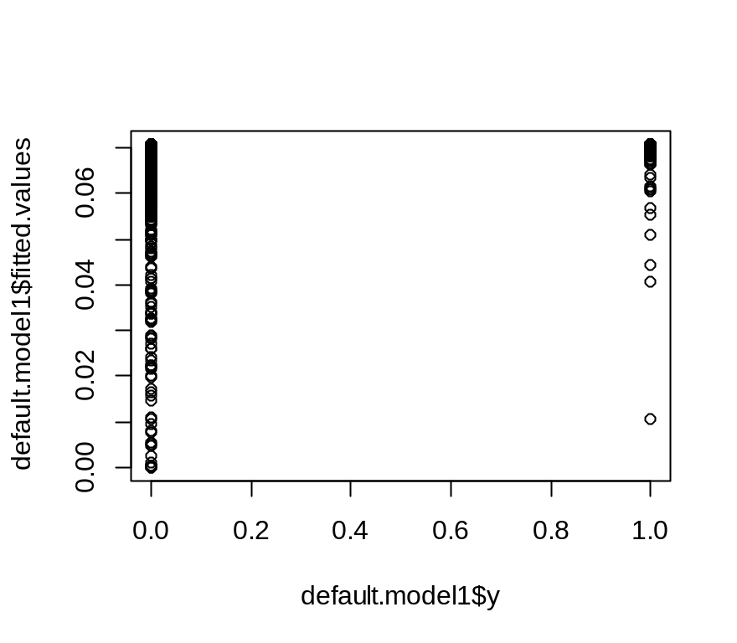

glm(as.factor(default1)~Total.assets+Total.term.liabilities...tangible.net.worth,family = binomial)

Call: glm(formula = as.factor(default1) ~ Total.assets + Total.term.liabilities...tangible.net.worth,
family = binomial)

Coefficients:
(Intercept)
-2.726e+00
Total.assets
-1.507e-05
Total.term.liabilities...tangible.net.worth
4.913e-02

Degrees of Freedom: 3540 Total (i.e. Null); 3538 Residual
Null Deviance: 1771
Residual Deviance: 1667 AIC: 1673
> glm(as.factor(default1)~Networth.Next.Year+Profit.after.tax,family = binomial)

Call: glm(formula = as.factor(default1) ~ Networth.Next.Year + Profit.after.tax,
family = binomial)

Coefficients:
(Intercept) Networth.Next.Year
3.767e+00 -7.048e+01
Profit.after.tax
-6.005e-04

Degrees of Freedom: 3540 Total (i.e. Null); 3538 Residual
Null Deviance: 1771
Residual Deviance: 0.7603 AIC: 6.76
Warning messages:
1: glm.fit: algorithm did not converge
2: glm.fit: fitted probabilities numerically 0 or 1 occurred
> glm(as.factor(default1)~Networth.Next.Year+Creditors.turnover,family = binomial)

Call: glm(formula = as.factor(default1) ~ Networth.Next.Year + Creditors.turnover,
family = binomial)

Coefficients:
(Intercept) Networth.Next.Year
2.7039 -65.3996
Creditors.turnover
0.7507

Degrees of Freedom: 3540 Total (i.e. Null); 3538 Residual
Null Deviance: 1771
Residual Deviance: 0.8613 AIC: 6.861
Warning messages:
1: glm.fit: algorithm did not converge
2: glm.fit: fitted probabilities numerically 0 or 1 occurred
> summary(glm(as.factor(default1)~Networth.Next.Year+Creditors.turnover,family = binomial))

Call:
glm(formula = as.factor(default1) ~ Networth.Next.Year + Creditors.turnover,
family = binomial)

Deviance Residuals:
Min 1Q Median 3Q Max
-0.299 0.000 0.000 0.000 0.360

Coefficients:
Estimate Std. Error z value Pr(>|z|)
(Intercept) 2.7039 1.3083 2.067 0.03876
Networth.Next.Year -65.3996 19.8797 -3.290 0.00100
Creditors.turnover 0.7507 0.2400 3.128 0.00176

(Intercept) *
Networth.Next.Year **
Creditors.turnover **
---
Signif. codes:
0 ‘***’ 0.001 ‘**’ 0.01 ‘*’ 0.05 ‘.’ 0.1 ‘ ’ 1

(Dispersion parameter for binomial family taken to be 1)

Null deviance: 1770.97315 on 3540 degrees of freedom
Residual deviance: 0.86126 on 3538 degrees of freedom
AIC: 6.8613

Number of Fisher Scoring iterations: 25

Warning messages:
1: glm.fit: algorithm did not converge
2: glm.fit: fitted probabilities numerically 0 or 1 occurred
>
> summary(glm(as.factor(default1)~Networth.Next.Year+Creditors.turnover,family = binomial))

Call:
glm(formula = as.factor(default1) ~ Networth.Next.Year + Creditors.turnover,
family = binomial)

Deviance Residuals:
Min 1Q Median 3Q Max
-0.299 0.000 0.000 0.000 0.360

Coefficients:
Estimate Std. Error z value Pr(>|z|)
(Intercept) 2.7039 1.3083 2.067 0.03876
Networth.Next.Year -65.3996 19.8797 -3.290 0.00100
Creditors.turnover 0.7507 0.2400 3.128 0.00176

(Intercept) *
Networth.Next.Year **
Creditors.turnover **
---
Signif. codes:
0 ‘***’ 0.001 ‘**’ 0.01 ‘*’ 0.05 ‘.’ 0.1 ‘ ’ 1

(Dispersion parameter for binomial family taken to be 1)

Null deviance: 1770.97315 on 3540 degrees of freedom
Residual deviance: 0.86126 on 3538 degrees of freedom
AIC: 6.8613

Number of Fisher Scoring iterations: 25

Warning messages:
1: glm.fit: algorithm did not converge
2: glm.fit: fitted probabilities numerically 0 or 1 occurred
>
> glm(as.factor(default1)~Networth.Next.Year+Profit.after.tax,family = binomial)

Call: glm(formula = as.factor(default1) ~ Networth.Next.Year + Profit.after.tax,
family = binomial)

Coefficients:
(Intercept) Networth.Next.Year
3.767e+00 -7.048e+01
Profit.after.tax
-6.005e-04

Degrees of Freedom: 3540 Total (i.e. Null); 3538 Residual
Null Deviance: 1771
Residual Deviance: 0.7603 AIC: 6.76
Warning messages:
1: glm.fit: algorithm did not converge
2: glm.fit: fitted probabilities numerically 0 or 1 occurred
>
> summary( glm(as.factor(default1)~Networth.Next.Year+Profit.after.tax,family = binomial))

Call:
glm(formula = as.factor(default1) ~ Networth.Next.Year + Profit.after.tax,
family = binomial)

Deviance Residuals:
Min 1Q Median 3Q Max
-0.2717 0.0000 0.0000 0.0000 0.2401

Coefficients:
Estimate Std. Error z value Pr(>|z|)
(Intercept) 3.767e+00 1.445e+00 2.607 0.009142
Networth.Next.Year -7.048e+01 2.017e+01 -3.494 0.000475
Profit.after.tax -6.005e-04 3.470e-03 -0.173 0.862623

(Intercept) **
Networth.Next.Year ***
Profit.after.tax
---
Signif. codes:
0 ‘***’ 0.001 ‘**’ 0.01 ‘*’ 0.05 ‘.’ 0.1 ‘ ’ 1

(Dispersion parameter for binomial family taken to be 1)

Null deviance: 1770.97315 on 3540 degrees of freedom
Residual deviance: 0.76033 on 3538 degrees of freedom
AIC: 6.7603

Number of Fisher Scoring iterations: 25

Warning messages:
1: glm.fit: algorithm did not converge
2: glm.fit: fitted probabilities numerically 0 or 1 occurred
>
> glm(as.factor(default1)~Networth.Next.Year+Total.assets,family = binomial)

Call: glm(formula = as.factor(default1) ~ Networth.Next.Year + Total.assets,
family = binomial)

Coefficients:
(Intercept) Networth.Next.Year
2.488987 -56.270232
Total.assets
0.006688

Degrees of Freedom: 3540 Total (i.e. Null); 3538 Residual
Null Deviance: 1771
Residual Deviance: 0.9772 AIC: 6.977
Warning messages:
1: glm.fit: algorithm did not converge
2: glm.fit: fitted probabilities numerically 0 or 1 occurred
> summary(glm(as.factor(default1)~Networth.Next.Year+Total.assets,family = binomial))

Call:
glm(formula = as.factor(default1) ~ Networth.Next.Year + Total.assets,
family = binomial)

Deviance Residuals:
Min 1Q Median 3Q Max
-0.3021 0.0000 0.0000 0.0000 0.3992

Coefficients:
Estimate Std. Error z value Pr(>|z|)
(Intercept) 2.488987 1.407811 1.768 0.07706
Networth.Next.Year -56.270232 18.343449 -3.068 0.00216
Total.assets 0.006688 0.015774 0.424 0.67157

(Intercept) .
Networth.Next.Year **
Total.assets
---
Signif. codes:
0 ‘***’ 0.001 ‘**’ 0.01 ‘*’ 0.05 ‘.’ 0.1 ‘ ’ 1

(Dispersion parameter for binomial family taken to be 1)

Null deviance: 1770.9732 on 3540 degrees of freedom
Residual deviance: 0.9772 on 3538 degrees of freedom
AIC: 6.9772

Number of Fisher Scoring iterations: 25

default.model2<-glm(as.factor(default1)~Total.assets+Debt.to.equity.ratio..times.,family = binomial)
> default.model3<-glm(as.factor(default1)~Profit.after.tax+Debt.to.equity.ratio..times.,family = binomial)
model4<-glm(as.factor(default1)~Total.term.liabilities...tangible.net.worth,family = binomial)

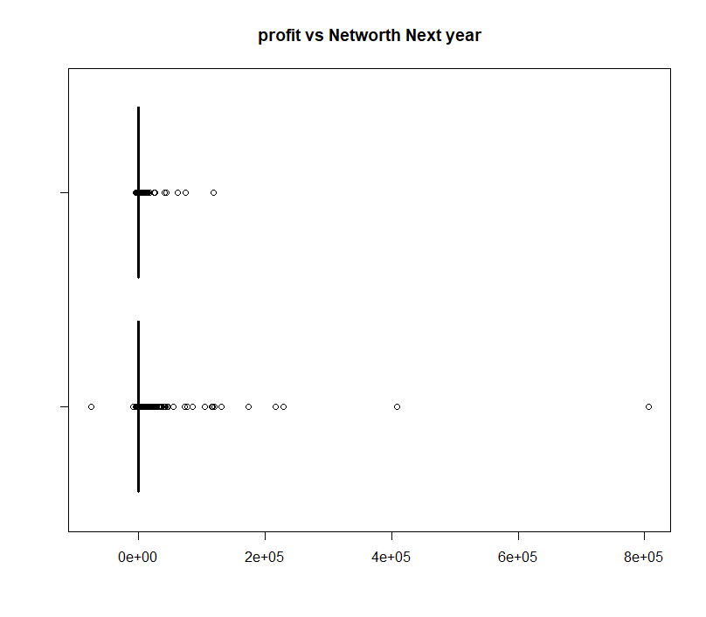

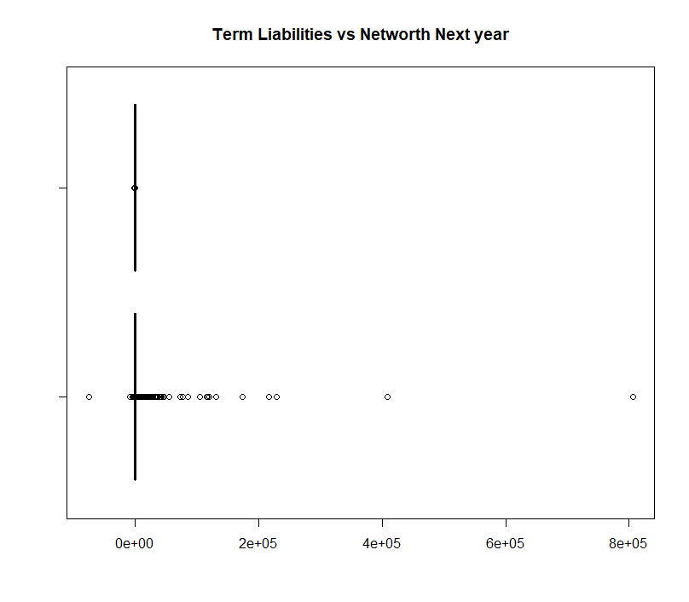
boxplot(Networth.Next.Year,Creditors.turnover,horizontal = TRUE,col = c("Red","Blue"),main="Credit turnover vs Networth Next year")

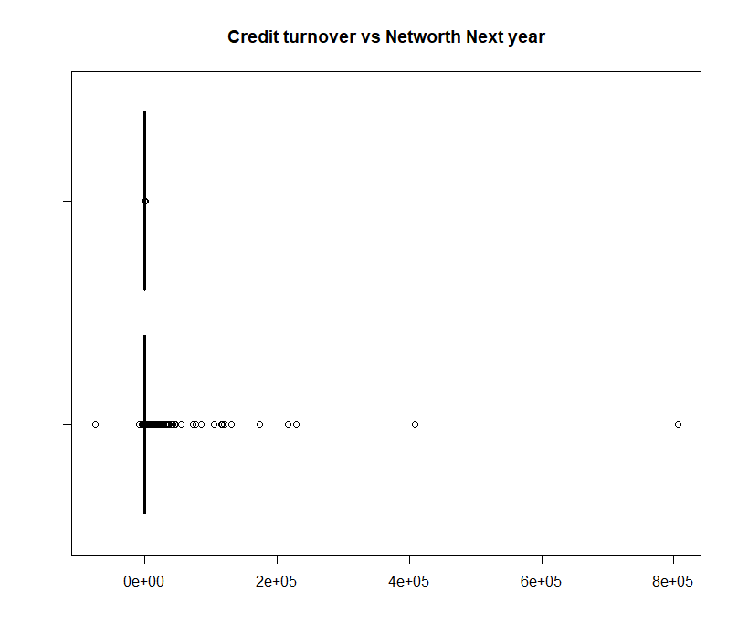

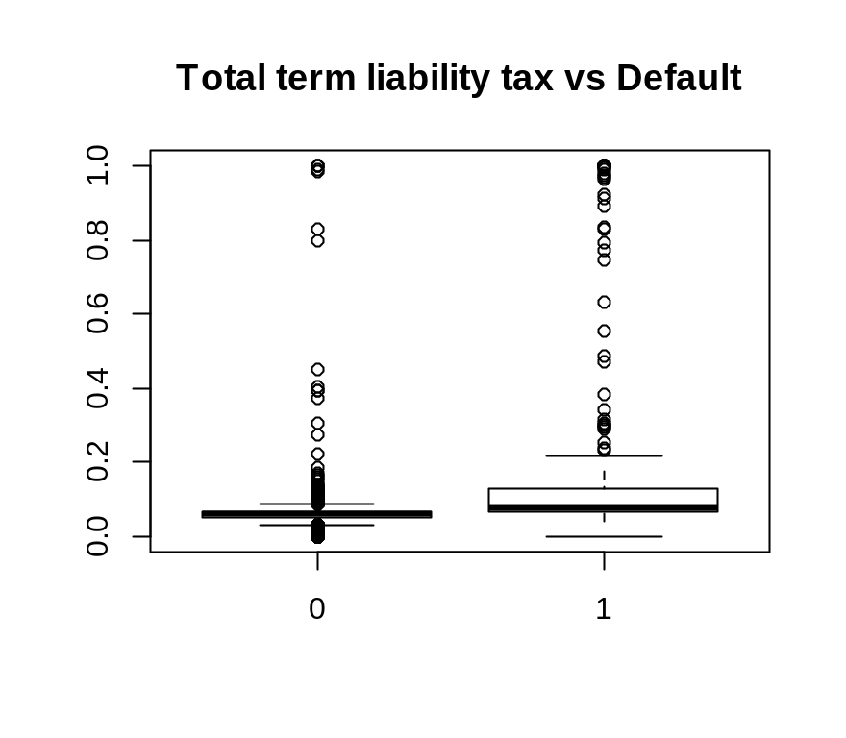

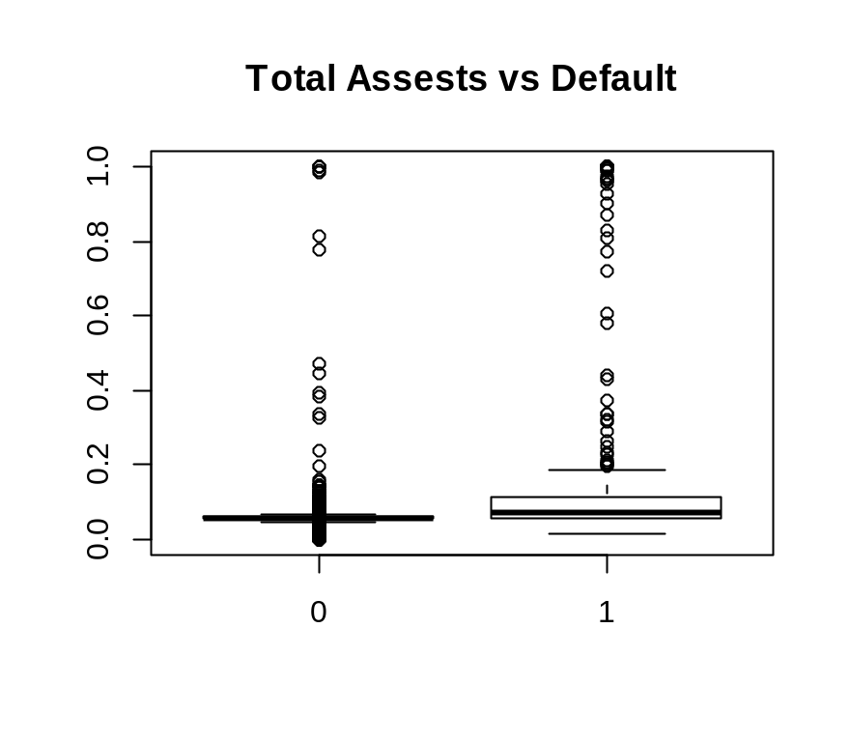

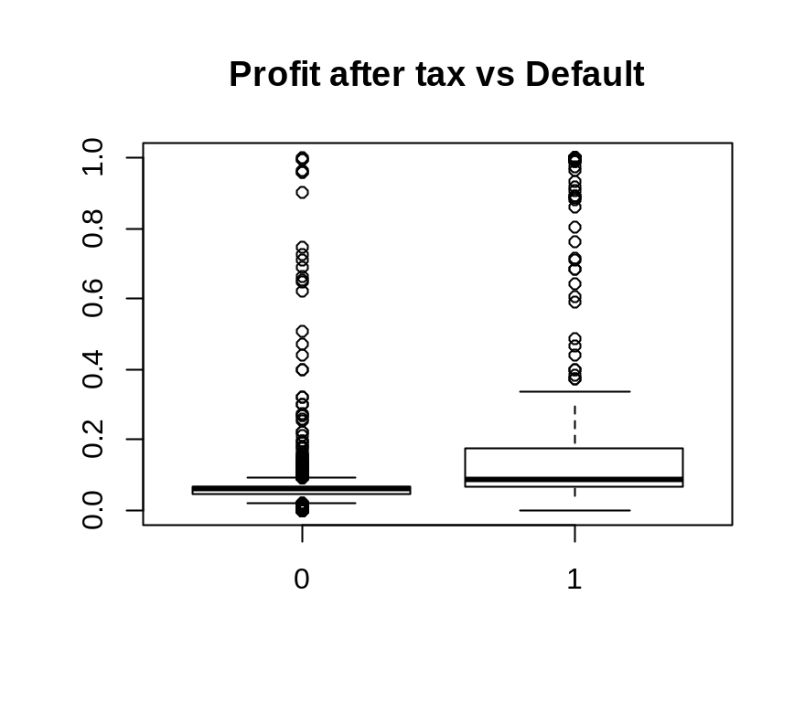

Summary(as.factor(default1))
0 1
3298 243
> 243/(3298+243)
[1] 0.06862468
> default.prediction2<-ifelse(default.model2$fitted.values>0.07,1,0)
> table(default.model2$y,default.prediction2)
default.prediction2
0 1
0 3122 176
1 112 131
> from the above figure model 2 here we predict 131, here missed 112, and predicted 126 incorrectly here 176 good companies predicted as default, 112 bad companies not predicted as default, we not able to detect bad companies we can change cutoff value
2519/(2519+779)
[1] 0.7637962
> (2519+166/(2519+779+77+166)
+

> (2519+166/(2519+779+77+166))
[1] 2519.047
> (2519+166/2519+779+77+166)
[1] 3541.066
> (2519+166)/(2519+779+77+166)
[1] 0.7582604
Efficency of Assests vs Netwoth next year is 0.7582604

1-(2519+166)/(2519+779+77+166)
[1] 0.2417396

Here misclassification is 24%

default.prediction3<-ifelse(default.model3$fitted.values>0.06,1,0)
> table(default.model3$y,default.prediction3)
default.prediction3
0 1
0 1522 1776
1 10 233
> 233/(10+233)
[1] 0.9588477
> (10+233)/(1522+1776+10+233)
[1] 0.06862468
> 1-(10+233)/(1522+1776+10+233)
[1] 0.9313753
> from the above figure model 3 here we predict 233, here missed 10, and predicted 126 incorrectly here 1776 good companies predicted as default, 233 bad companies not predicted as default, we not able to detect bad companies we can change cutoff value
Estimation is 0.9313753

,1,0)
> table(default.model4$y,default.prediction4)
default.prediction4
0 1
0 1582 1716
1 21 222
> 22/(21+222)
[1] 0.09053498
> [1] 0.9588477
Error: unexpected '[' in "["
> > (10+233)/(1522+1776+10+233)
Error: unexpected '>' in ">"
> [1] 0.06862468
Error: unexpected '[' in "["
> > 1-(10+233)/(1522+1776+10+233)
Error: unexpected '>' in ">"
> [1] 0.9313753
Error: unexpected '[' in "["
> 21/(21+222)
[1] 0.08641975
> (21+222)/(21+222)+1582+1716)
Error: unexpected ')' in "(21+222)/(21+222)+1582+1716)"
> (21+222)/21+222+1582+1716)
Error: unexpected ')' in "(21+222)/21+222+1582+1716)"
> 21+222/21+222+1582+1716
[1] 3551.571
> (21+222)/(21+222+1582+1716)
[1] 0.06862468
> 1-(21+222)/(21+222+1582+1716)
[1] 0.9313753

We can conclude that term liabilities I s having strong value

